(Head Coach Name ) (Name) (Phone Number)
(Trainer Name ) (Name) (Phone Number)
(Asst Coach Name ) (Name) (Phone Number)
(Asst Coach Name ) (Name) (Phone Number)

Emergency Medical Services Phone Number: Police Department 911 or 732-938-4111

EMS Contact Protocol

The location, Soldier Memorial Park and its street address 793 Lakewood Farmingdale Road are listed within the Computer Aided Dispatch (CAD) System of the Howell Township Police Department however this physical street address would not be helpful in directing emergency personnel to an emergency scene on-site. Any call for emergency assistance should begin with “I am at Soldier Memorial Park on (address) and need EMS for ……….” There is no need to mention Lincoln Field unless the 911 operator expresses familiarity with this nomenclature and asks for verification. You will provide immediately after identifying the location and need for EMS the number of individuals injured, nature of injuries, condition of injured, first aid treatment, your name, title, telephone number, 793 Lakewood Farmingdale Road and other information as requested.

Scene Control: Limit scene to first aid providers, move bystanders away from the area, and maintain clear egress for entrance and exit of EMS vehicles, personnel, and apparatus. The entrance of Soldier Memorial Park must remain clear of vehicular obstruction as indicated by the painted warning lines upon the pavement at that location.

Facility Address
Soldier Memorial Park 793 Lakewood Farmingdale Road Howell, New Jersey 07731

AED Unit Location

NONE ON PREMISE

Hospitals

- Centra State Healthcare System 901 Main Street
Freehold, NJ 07728 Emergency Department: 732-431-2000
- Jersey Shore University Medical Center 1945 NJ-33
Neptune City, NJ 07753 Emergency Department: 732-775-5500
Area of Safe Refuge: Parents must plan in advance based upon the weather forecast to remain at the fields in case of lightning, thunder, or inclement conditions. The sighting of lightning or sound of thunder will be cause for immediate evacuation from the fields and into the area of safe refuge identified as parent vehicles. A minimum wait time of 30 minutes must pass prior to return to the fields after each sound of thunder or appearance of lightning. All staff members will leave the field and enter their personal vehicles without delay.
This facility isn’t equipped with a lightning detection system that provides warning via audible horn blasts. Weather safety devices of this nature are designed to alert us of the presence of lightning danger, however we must not allow for a lack of audible warning to supersede common sense, perception, and awareness of the sight of lightning or the sound of thunder.
Staff Designations
Head Coaches or non-volunteer coaching staff member assigned to oversee team training sessions and matches
Assistant Coaches or the designated adult for each team commonly referred to as the parent manager that provides support and assistance to the head coach
Emergency Task Assignment Recommendations

Maintain fully stocked first aid kit Head Coach
Possesses medical release forms Head Coach
Immediate care of the injured or ill participant Head Coach
Be aware of exact location and egress options for EMS Head Coach and Assistant Coach
Emergency equipment retrieval Assistant Coach
Call EMS Assistant Coach
Flag down EMS and direct to scene Assistant Coach

Recommendations for EMS Transport of an Injured Child with No Parent or Guardian Present
Assistant Coach
- Accompanies injured child to the hospital during EMS transport with that child’s medical release form. Medical staff will perhaps request this original form prior to examination and/or treatment or might otherwise ask for a coach to sign a permission to treat. A completed medical release form signed by a parent or guardian should suffice for this purpose.
- Establishes contact with the injured child’s parent or guardian through the use of phone numbers and names listed upon that child’s emergency contact form.
- Remains with the injured child at the hospital until a parent or guardian arrives to assume care and custody.
- Documents in writing the times of transport to the hospital and arrival of the named parent or guardian that assumed care and custody of the child.
Head Coach
- Remains with the team until dismissal of players to their parents or guardians.
- Establishes contact with the Assistant Coach following the post-match player dismissal to obtain update on the injured child’s condition, name and address of the hospital, status on the contact with the child’s parent or guardian and his or her estimated time of arrival,
- Establishes contact with the Trustee or the Director of Coaching to advise of the situation. A coordinated staff effort will be organized by the Trustee or Director of Coaching to provide relief to the staff member at the hospital with the injured child.
- Responsible for completion of accident/ injury report relating to the matter.
- Responsible for maintaining at all team events the team’s the folder that contains each player’s medical release and emergency contact forms
Potential Exposure to COVID-19
Individuals (staff members or players) who have symptoms upon arrival to program events or who become sick during an event should immediately be separated from others by a designated staff member equipped with personal protection face mask and non-latex gloves. Pick-up arrangements should be made based upon the emergency contact/s of the staff member or player. This aims to ensure that the staff member or player receives safe transportation to his or her home or to a healthcare provider.
The facility, in most cases, does not need to be shut down although any items touched by the sick person should be disinfected. Waiting 24 hours before cleaning and disinfecting these items is recommended to minimize potential for assigned staff members for being exposed to respiratory droplets. Continued cleaning and disinfecting of all high-touch surfaces within the facility is also advised.
Follow the CDC cleaning and disinfection recommendations:
- Clean dirty surfaces with soap and water before disinfecting them.
- To disinfect surfaces, use products that meet EPA criteria for use against SARS-Cov-2external icon, the virus that causes COVID-19, and are appropriate for the surface.
- Always wear gloves and gowns appropriate for the chemicals being used when you are cleaning and disinfecting.
- You may need to wear additional PPE depending on the setting and disinfectant product you are using. For each product you use, consult, and follow the manufacturer’s instructions for use.
Determinations should be made relating to any staff members or players that may have been exposed to the virus and may need to take additional precautions. Notification relating to this potential exposure should be made to the parent or guardian of each player and each staff member. Confidentiality must be maintained. These potentially exposed individuals should quarantine for 14 days and self-monitor for symptoms.
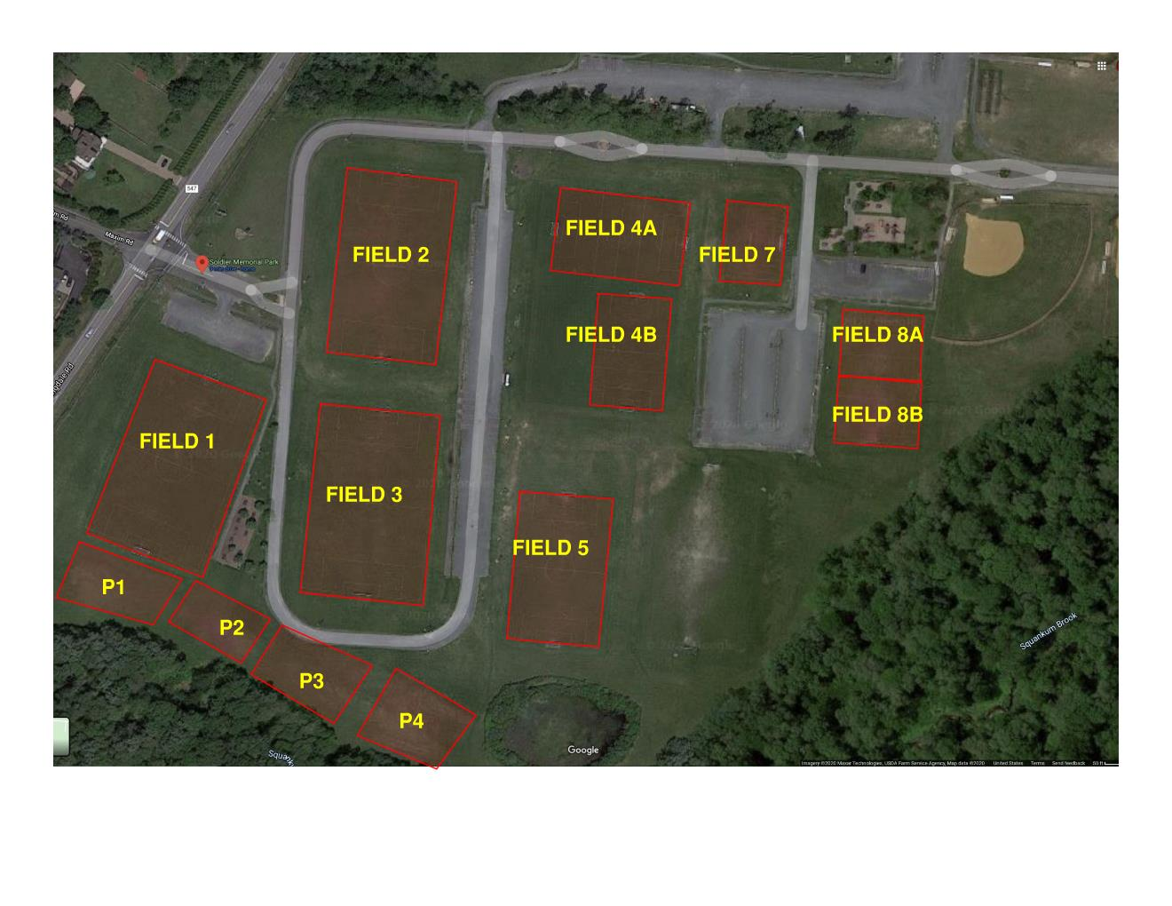
Soldier Memorial Park

